Practice 9

**Part 1**

1. The staff in the HR department want to hide some of the data in the EMPLOYEES table. They want a view called EMPLOYEES_VU based on the employee numbers, employee names, and department numbers from the EMPLOYEES table. They want the heading for the employee name to be EMPLOYEE.
2. Confirm that the view works. Display the contents of the EMPLOYEES_VU view.

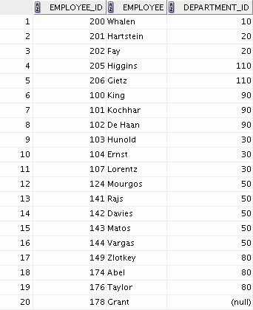

1. Using your EMPLOYEES_VU view, write a query for the HR department to display all employee names and department numbers.



**…**



1. Department 50 needs access to its employee data. Create a view named DEPT50 that contains the employee numbers, employee last names, and department numbers for all employees in department 50. You are asked to label the view columns EMPNO, EMPLOYEE, and DEPTNO.
2. Display the structure and contents of the DEPT50 view.

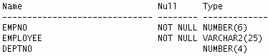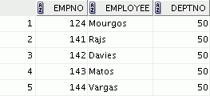

Part 2

1. You need a sequence that can be used with the primary key column of the DEPT table. The sequence should start at 200 and have a maximum value of 1,000. Have your sequence increment by 10. Name the sequence DEPT_ID_SEQ.
2. To test your sequence, write a script to insert two rows in the DEPT table. Name your script lab_10_08.sql. Be sure to use the sequence that you created for the ID column. Add two departments: Education and Administration. Confirm your additions. Run the commands in your script.
3. Create a nonunique index on the NAME column in the DEPT table.
4. Create a synonym for your EMPLOYEES table. Call it EMP.